Chapter 11, Problem 23.

Using Fig. 11.54, design a problem to help other students to better understand how to find the rms value of a waveshape.
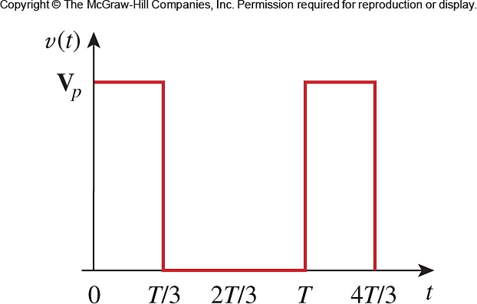

Figure 11.54
For Prob. 11.23.

